## Using Tags to Organize Resources

### Lab Overview

In this lab, you will learn how to use Azure Tags to categorize and view resources across resource groups.

### Exercise 1: Use Tags to Navigate the Azure Portal

1. Open the Azure Portal (https://portal.azure.com), open **Resource groups** and click the **Add** button.

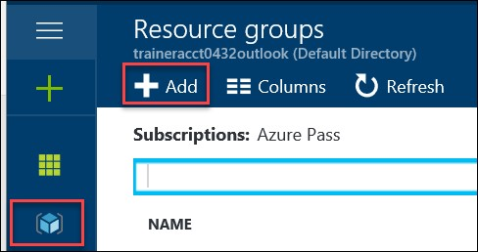

1. In the **Resource group** blade, type **HRDEV** for the **Resource group name**, choose the nearest region for the **Resource group location** then click the **Create** button.

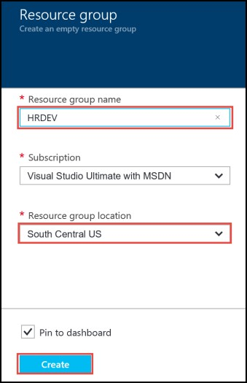

1. Repeat steps 1 and 2 to create another resource group called **HRPROD**.

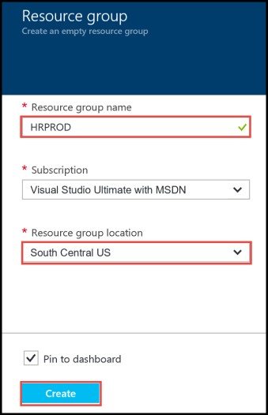

1. Open the HRDEV resource group and click the Tags menu.

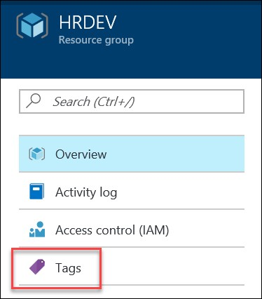

1. On the **Tags** blade, create a tag with a key of **ENV** and a value of **DEVELOPMENT** then click the **Save** button.

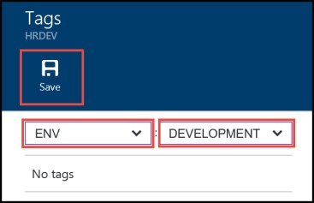

1. On the **Tags** blade, create another tag with a key of **COST CENTER** and a value of **HR** then click the **Save** button.

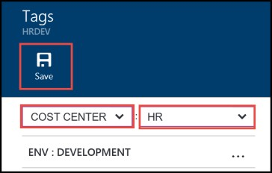

1. Open the **HRPROD** resource group and click the Tags menu.

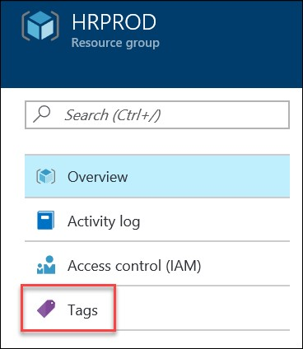

1. On the **Tags** blade click the **Key** dropdown and choose the **ENV** key from the list. Type **PROD** for the **Value**. Click the **Save** button.

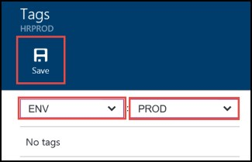

1. On the **Tags** blade type **COST CENTER** for thekey and type **HR** for the **Value**. Click the **Save** button.

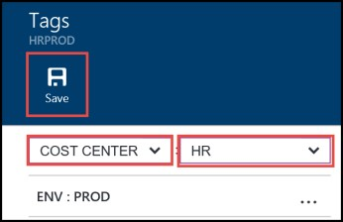

1. In the Azure Portal click **More services**, then type **Tags** into the filter bar. Select Tags from the filter results.

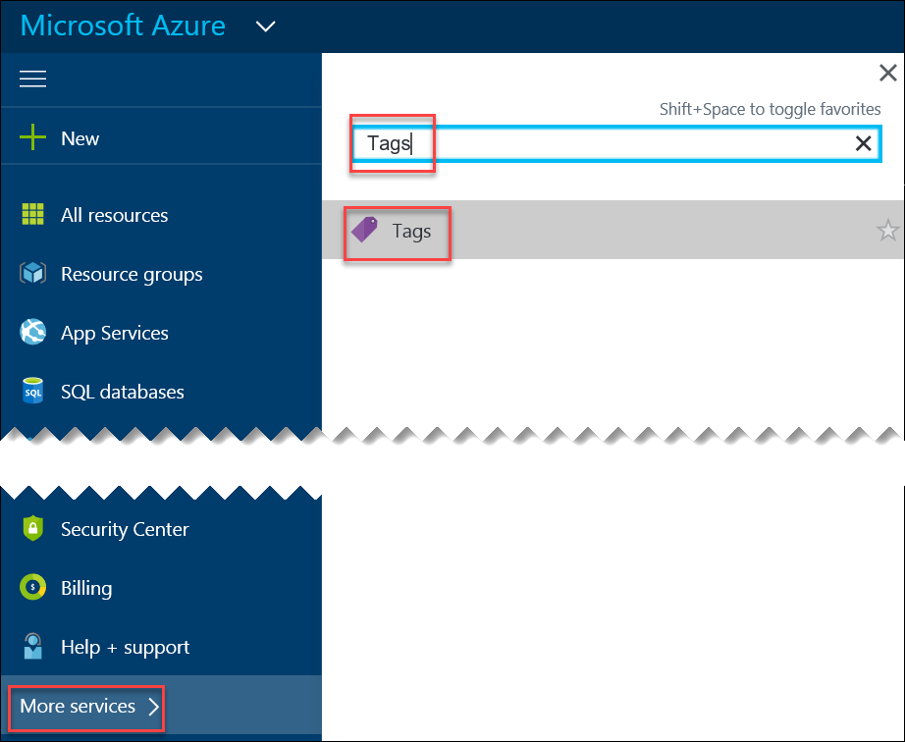

1. On the **Tags** blade you will see all of the tags we created for our resource groups. Click the **COST CENTER: HR** tag to view the resource groups included in the HR cost center. Notice this shows both HR resource groups since they both belong to HR.

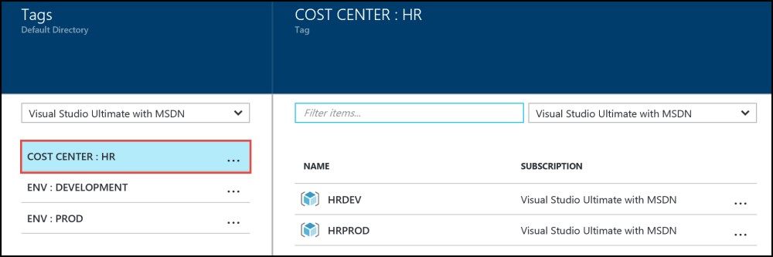

1. Now click the other tags to view the PROD and DEVELOPMENT environments respectively. Under the **ENV: DEVELOPMENT** tag you will only see the HRDEV resource group and under the **ENV: PROD** tag you will only see the HRPROD resource group.

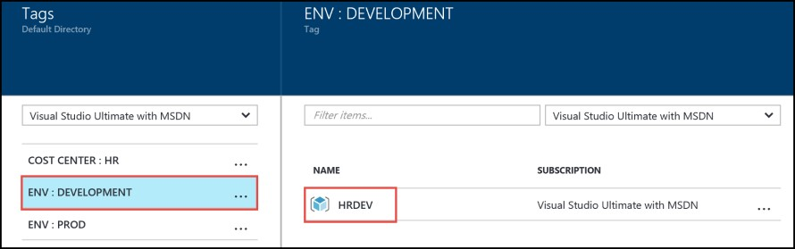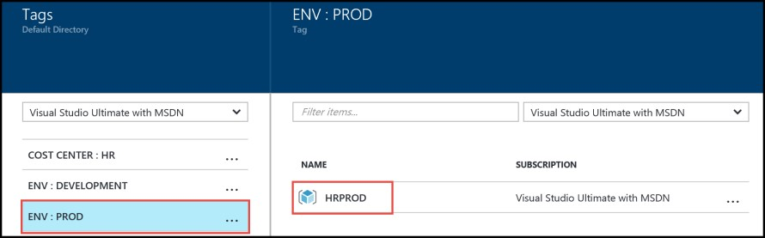

### Lab Summary

In this lab, you learned how to use Azure Tags to categorize and view resources across resource groups.